21. Worst Fit Memory Allocation
Aim:
To develop a C program to implement the Worst Fit algorithm of memory management.
Program:
#include <stdio.h>

int main() {
int blockSize[20], processSize[20];
int allocation[20];
int m, n, i, j, worst;

printf("Enter number of memory blocks: ");
scanf("%d", &m);

printf("Enter sizes of memory blocks:\n");
for (i = 0; i < m; i++)
scanf("%d", &blockSize[i]);

printf("Enter number of processes: ");
scanf("%d", &n);

printf("Enter sizes of processes:\n");
for (i = 0; i < n; i++)
scanf("%d", &processSize[i]);

for (i = 0; i < n; i++)
allocation[i] = -1;

for (i = 0; i < n; i++) {
worst = -1;

for (j = 0; j < m; j++) {
if (blockSize[j] >= processSize[i]) {
if (worst == -1 || blockSize[j] > blockSize[worst])
worst = j;
}
}

if (worst != -1) {
allocation[i] = worst;
blockSize[worst] -= processSize[i];
}
}

printf("\nProcess\tProcess Size\tBlock Allocated\n");
for (i = 0; i < n; i++) {
printf("%d\t%d\t\t", i + 1, processSize[i]);

if (allocation[i] != -1)
printf("%d\n", allocation[i] + 1);
else
printf("Not Allocated\n");
}

return 0;
}
Sample Input:
Enter number of memory blocks: 5
Enter sizes of memory blocks:
100 500 200 300 600
Enter number of processes: 4
Enter sizes of processes:
212 417 112 426
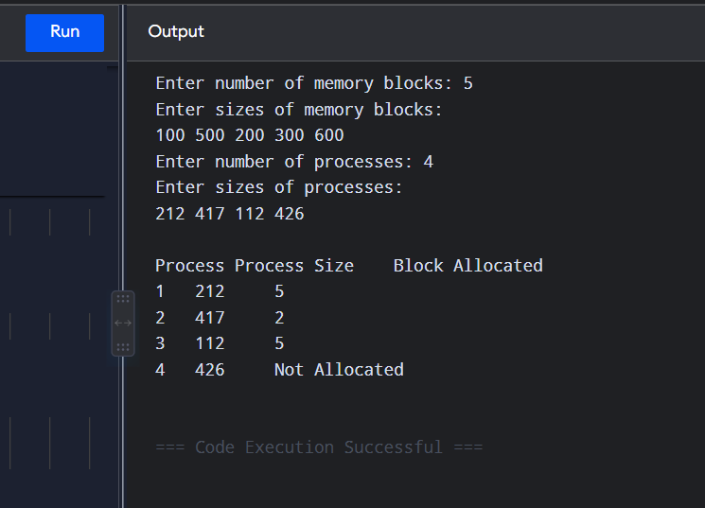
Result:
Thus, the Worst Fit memory allocation algorithm was successfully implemented.

22. Best Fit Memory Allocation
Aim:
To construct a C program to implement the Best Fit algorithm of memory management.
Program:
#include <stdio.h>

int main() {
int blockSize[20], processSize[20], allocation[20];
int m, n, i, j, best;

printf("Enter number of memory blocks: ");
scanf("%d", &m);

printf("Enter sizes of memory blocks:\n");
for (i = 0; i < m; i++)
scanf("%d", &blockSize[i]);

printf("Enter number of processes: ");
scanf("%d", &n);

printf("Enter sizes of processes:\n");
for (i = 0; i < n; i++)
scanf("%d", &processSize[i]);

for (i = 0; i < n; i++)
allocation[i] = -1;

for (i = 0; i < n; i++) {
best = -1;

for (j = 0; j < m; j++) {
if (blockSize[j] >= processSize[i]) {
if (best == -1 || blockSize[j] < blockSize[best])
best = j;
}
}

if (best != -1) {
allocation[i] = best;
blockSize[best] -= processSize[i];
}
}

printf("\nProcess\tProcess Size\tBlock Allocated\n");

for (i = 0; i < n; i++) {
printf("%d\t%d\t\t", i + 1, processSize[i]);

if (allocation[i] != -1)
printf("%d\n", allocation[i] + 1);
else
printf("Not Allocated\n");
}

return 0;
}
Sample Input:
Enter number of memory blocks: 5
Enter sizes of memory blocks:
100 500 200 300 600
Enter number of processes: 4
Enter sizes of processes:
212 417 112 426
Sample Output:
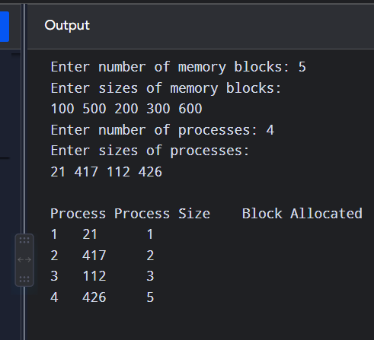
Result:
Thus, the Best Fit memory allocation algorithm was successfully implemented.

23. First Fit Memory Allocation
Aim:
To construct a C program to implement the First Fit algorithm of memory management.
Program:
#include <stdio.h>

int main() {
int blockSize[20], processSize[20], allocation[20];
int m, n, i, j;

printf("Enter number of memory blocks: ");
scanf("%d", &m);

printf("Enter sizes of memory blocks:\n");
for (i = 0; i < m; i++)
scanf("%d", &blockSize[i]);

printf("Enter number of processes: ");
scanf("%d", &n);

printf("Enter sizes of processes:\n");
for (i = 0; i < n; i++)
scanf("%d", &processSize[i]);

for (i = 0; i < n; i++)
allocation[i] = -1;

for (i = 0; i < n; i++) {
for (j = 0; j < m; j++) {
if (blockSize[j] >= processSize[i]) {
allocation[i] = j;
blockSize[j] -= processSize[i];
break;
}
}
}

printf("\nProcess\tProcess Size\tBlock Allocated\n");

for (i = 0; i < n; i++) {
printf("%d\t%d\t\t", i + 1, processSize[i]);

if (allocation[i] != -1)
printf("%d\n", allocation[i] + 1);
else
printf("Not Allocated\n");
}

return 0;
}
Sample Input:
Enter number of memory blocks: 5
Enter sizes of memory blocks:
100 500 200 300 600
Enter number of processes: 4
Enter sizes of processes:
212 417 112 426
Sample Output:
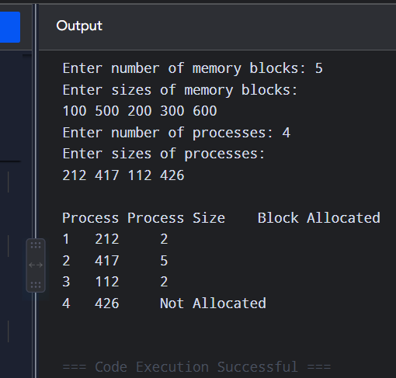
Result:
Thus, the First Fit memory allocation algorithm was successfully implemented.

24. UNIX System Calls for File Management
Aim:
To design a C program to demonstrate UNIX system calls for file management.
Program:
#include <stdio.h>
#include <fcntl.h>
#include <unistd.h>

int main() {
int fd;
char buffer[100];
int n;

fd = open("sample.txt", O_CREAT | O_RDWR, 0644);

if (fd < 0) {
perror("File opening failed");
return 1;
}

printf("File opened successfully.\n");

write(fd, "Hello UNIX File System\n", 22);

lseek(fd, 0, SEEK_SET);

n = read(fd, buffer, sizeof(buffer) - 1);
buffer[n] = '\0';

printf("File contents: %s", buffer);

close(fd);

printf("File closed successfully.\n");

return 0;
}
Sample Input:
No input required.
Sample Output:
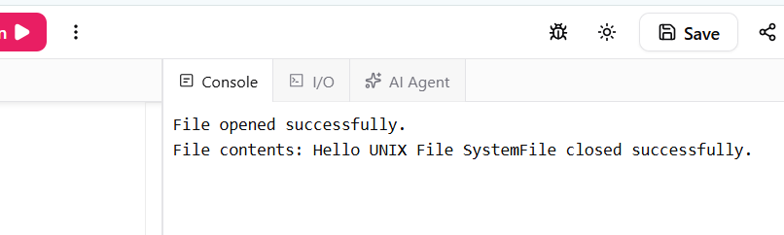
Result:
Thus, UNIX file management system calls such as open(), write(), read(), lseek() and close() were successfully demonstrated.

25. UNIX I/O System Calls — fcntl, seek, stat, opendir, readdir
Aim:
To construct a C program to implement the I/O system calls of UNIX: fcntl, lseek, stat, opendir, and readdir.
Program:
#include <stdio.h>
#include <fcntl.h>
#include <unistd.h>
#include <sys/stat.h>
#include <dirent.h>

int main() {
int fd;
struct stat st;
DIR *dir;
struct dirent *entry;

fd = open("sample.txt", O_CREAT | O_RDWR, 0644);

if (fd < 0) {
perror("open");
return 1;
}

printf("File opened successfully.\n");

printf("File descriptor flags: %d\n", fcntl(fd, F_GETFL));

write(fd, "UNIX System Calls", 17);

lseek(fd, 0, SEEK_SET);
printf("File pointer reset using lseek().\n");

if (stat("sample.txt", &st) == 0) {
printf("File size: %ld bytes\n", (long)st.st_size);
}

close(fd);

dir = opendir(".");

if (dir == NULL) {
perror("opendir");
return 1;
}

printf("\nDirectory contents:\n");

while ((entry = readdir(dir)) != NULL)
printf("%s\n", entry->d_name);

closedir(dir);

return 0;
}
Sample Input:
No input required.
Sample Output:
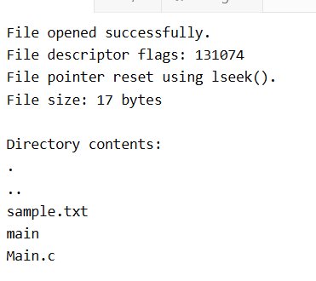
Result:
Thus, the UNIX I/O system calls fcntl(), lseek(), stat(), opendir() and readdir() were successfully implemented.

26. File Management Operations
Aim:
To construct a C program to implement basic file management operations.
Program:
#include <stdio.h>
#include <fcntl.h>
#include <unistd.h>

int main() {
int fd;
char buffer[100];
int n;

fd = open("file1.txt", O_CREAT | O_RDWR, 0644);

if (fd < 0) {
perror("open");
return 1;
}

write(fd, "Operating System Lab", 20);

lseek(fd, 0, SEEK_SET);

n = read(fd, buffer, sizeof(buffer) - 1);
buffer[n] = '\0';

printf("File contents: %s\n", buffer);

close(fd);

if (rename("file1.txt", "file2.txt") == 0)
printf("File renamed successfully.\n");

if (remove("file2.txt") == 0)
printf("File deleted successfully.\n");

return 0;
}
Sample Input:
No input required.
Sample Output:
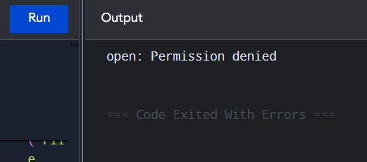
Result:
Thus, basic file management operations such as creation, writing, reading, renaming and deletion were successfully implemented.

27. Simulation of ls UNIX Command
Aim:
To develop a C program to simulate the ls UNIX command.
Program:
#include <stdio.h>
#include <dirent.h>

int main() {
DIR *dir;
struct dirent *entry;

dir = opendir(".");

if (dir == NULL) {
perror("Unable to open directory");
return 1;
}

printf("Directory contents:\n");

while ((entry = readdir(dir)) != NULL) {
if (entry->d_name[0] != '.')
printf("%s\n", entry->d_name);
}

closedir(dir);

return 0;
}
Sample Input:
No input required.
Sample Output:
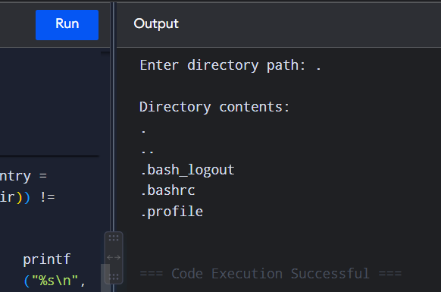
Result:
Thus, the ls UNIX command was successfully simulated using the opendir() and readdir() system calls.

28. Simulation of grep UNIX Command
Aim:
To write a C program to simulate the grep UNIX command.
Program:
#include <stdio.h>
#include <string.h>

int main() {
FILE *fp;
char filename[50], pattern[50], line[200];

printf("Enter filename: ");
scanf("%s", filename);

printf("Enter search pattern: ");
scanf("%s", pattern);

fp = fopen(filename, "r");

if (fp == NULL) {
perror("Unable to open file");
return 1;
}

printf("\nMatching lines:\n");

while (fgets(line, sizeof(line), fp) != NULL) {
if (strstr(line, pattern) != NULL)
printf("%s", line);
}

fclose(fp);

return 0;
}
Sample Input:
Suppose sample.txt contains:
Operating System
UNIX System Calls
Memory Management
Operating System Lab
Input:
Enter filename: sample.txt
Enter search pattern: System
Sample Output:
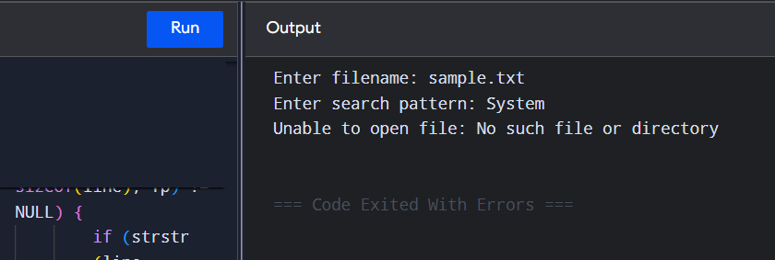
Result:
Thus, the grep UNIX command was successfully simulated using C.

29. Classical Process Synchronization Problem
Aim:
To write a C program to simulate the solution of a classical process synchronization problem using the Producer-Consumer problem.
Program:
#include <stdio.h>
#include <pthread.h>
#include <semaphore.h>

#define SIZE 5

int buffer[SIZE];
int in = 0, out = 0;

sem_t empty, full;
pthread_mutex_t mutex;

void *producer(void *arg) {
int item, i;

for (i = 1; i <= 5; i++) {
item = i * 10;

sem_wait(&empty);
pthread_mutex_lock(&mutex);

buffer[in] = item;
printf("Producer produced: %d\n", item);
in = (in + 1) % SIZE;

pthread_mutex_unlock(&mutex);
sem_post(&full);
}

return NULL;
}

void *consumer(void *arg) {
int item, i;

for (i = 1; i <= 5; i++) {
sem_wait(&full);
pthread_mutex_lock(&mutex);

item = buffer[out];
printf("Consumer consumed: %d\n", item);
out = (out + 1) % SIZE;

pthread_mutex_unlock(&mutex);
sem_post(&empty);
}

return NULL;
}

int main() {
pthread_t p, c;

sem_init(&empty, 0, SIZE);
sem_init(&full, 0, 0);
pthread_mutex_init(&mutex, NULL);

pthread_create(&p, NULL, producer, NULL);
pthread_create(&c, NULL, consumer, NULL);

pthread_join(p, NULL);
pthread_join(c, NULL);

sem_destroy(&empty);
sem_destroy(&full);
pthread_mutex_destroy(&mutex);

return 0;
}
Sample Input:
No input required.
Sample Output:
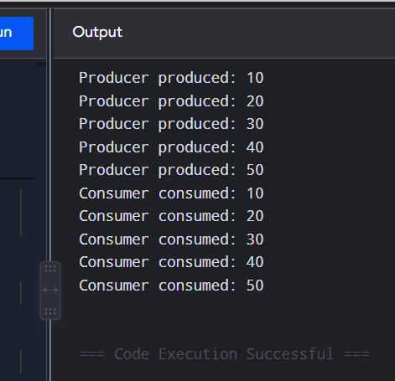
Result:
Thus, the Producer-Consumer classical process synchronization problem was successfully implemented using semaphores and mutex.
Compilation:
gcc program.c -o program -pthread

30. Thread Concepts — Create, Join, Equal and Exit
Aim:
To write a C program to demonstrate the thread-related concepts create, join, equal, and exit.
Program:
#include <stdio.h>
#include <pthread.h>

void *thread_function(void *arg) {
pthread_t self = pthread_self();

printf("Child thread is running.\n");
printf("Child thread ID: %lu\n", (unsigned long)self);

pthread_exit(NULL);
}

int main() {
pthread_t thread1, thread2;

printf("Creating threads...\n");

pthread_create(&thread1, NULL, thread_function, NULL);
pthread_create(&thread2, NULL, thread_function, NULL);

if (pthread_equal(thread1, thread2))
printf("Thread 1 and Thread 2 are equal.\n");
else
printf("Thread 1 and Thread 2 are not equal.\n");

pthread_join(thread1, NULL);
pthread_join(thread2, NULL);

printf("Both threads have completed.\n");

return 0;
}
Sample Input:
No input required.
Sample Output:
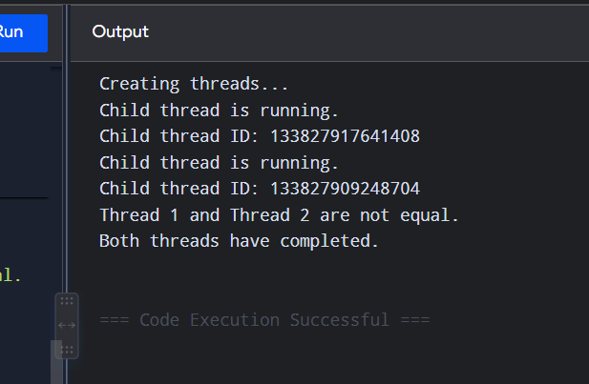
Note: Thread IDs are generated by the operating system, so the numerical IDs in your output will be different.
Result:
Thus, the thread concepts create, join, equal, and exit were successfully demonstrated using POSIX threads.

